

MMHH to CBOEdirect
Business Requirements
(WR# 6228)

Prepared By: Raghuram Tirumalasetti
Last Modified: 21st September 2009

Approved By:

______________________
Anthony Montesano
Trading Operations Division

______________________
Charlie Hullihan
Trading Operations Division

______________________
Mark Novak
Systems Division

Approved Version
CBOE Confidential & Proprietary

MMHH to CBOEdirect - Business Requirements Document Distribution List

Staff
Anthony Montesano
Bob Peterson
Bobbie Piwnicki
Brad Samuels
Charlie Hullihan
Chris Hield
Curt Schumacher
Dave Hultquist
Dave Schmitz
Dave Wegener
Don Zagorski
Keith Kiley
Linda Gerdes
Mark Novak
Mark Woyna
Mayur Patel
Mike Trees
Patrick Sexton
Ravi Vazirani
Raghuram Tirumalasetti
Stella Ulyanov
Steve Chodash
Tim Watkins
Todd Furney
Tom Busch
Tom Lynch

Table of Contents

1 Introduction 4
1.1 Background 4
1.2 Key Business Drivers 4
1.3 Business Goal 4
1.4 Purpose and Scope of this document 4
2 Business Requirements 5
2.1 General Assumptions 5
2.1.1 Assumptions 5
2.1.2 Dependencies 5
2.2 Market Maker Trade Notification (MMTN) 6
2.2.1 Business Flow and Sequence Diagrams 6
2.2.2 New Parameters 7
2.2.3 Market Maker Trade Notification (MMTN) details 8
2.3 Trade generated from Market Maker Hand Held(s) 10
2.3.1 Business Flow and Sequence Diagrams 10
2.3.2 MMHH to MMHH Trade 11
2.3.3 MMHH Trade Handling 13
3 Appendix 14
3.1 Hard Edit Errors generated currently by CTMr 14
3.2 Soft Edit Errors generated currently by CTMr 15
3.3 Fields for PAR Trade 15
4 Open Issues/Questions 17
5 Abbreviations and Acronyms 18

Introduction

Background
The Market Maker AP Server Network (generally referred to as the Market Maker Hand Held System (MMHH System) was developed as an alternative to paper ticket trading. It allows Firm traders the ability to electronically enter their trades on a firm's handheld device and send them for processing to the MMHH System via the NCC interface on the standalone server, AP92. Also the AP servers send the ETNs received from TPF to the AP 92 standalone server, which acts as a gateway to CTM (CBOE Trade Match) and the Non-CBOE Computers (NCC). ETN trades can either be accepted or rejected. If accepted, the trade information contained in the ETN Trade is collected and re-submitted as a new trade. If rejected, a notice is sent to the TSS service and the originator of the ETN is notified.

The current MMHH System is coded in ‘C’ language and is more complex and intricate than it needs to be as of date. Providing support for such a complex MMHH System is becoming increasingly difficult. Most of the legacy upstream and downstream systems that the MMHH System connects to have either gradually been phased out or in the process of being decommissioned. And notably of all the functionalities that the MMHH System was designed and developed to serve initially, only a small number of functionalities are really being used today. Thus CBOE is planning to streamline and update the current MMHH System.

Key Business Drivers
The key business drivers for initiating this project are:
- Reduced availability of resources to support the legacy MMHH System
- Plans to streamline and update the current MMHH System

Business Goal
The MMHH System – Rewrite project is an initiative by CBOE to revamp the existing MMHH System with latest technology and an even more efficient workflow.

Purpose and Scope of this document
This document details the business requirements for implementation of the new MMHH System. This document is mainly intended to capture only the eliminations and modifications planned to the existing MMHH System but not to detail all of the As-Is existing working/flows, business rules and validations of the existing MMHH System.

The document mainly addresses the following features:
- MMHH Trade Notification from OHS
- MMHH Trade to the Trade Server

Business Requirements

General Assumptions

Assumptions
- The existing Electronic Trade Notification (ETN) generation mechanism will be eliminated gradually
- The roll-out strategy for this project would involve handling and supporting both the MMTNs and ETNs until the ETNs are fully eliminated
- There will be No Accepts, No Rejects, and No Time-Outs of MMTNs
- The existing ability to modify a trade generated from MMHH will be eliminated and only deletes will be allowed
- The existing ability of CTM to provide 'Trade Match and Bust Notifications' will be eliminated
- A PAR Trade is submitted for a single price point only but can contain multiple contras
- An order traded on PAR with MMHHs for multiple price points will have a single PAR Trade submitted for each corresponding price point (i.e. results in multiple PAR Trades for an order)
- For a PAR Trade, the Trade Type in the Trade Reports sent to CTMr will be marked as ‘P’ indicating that it is a PAR Trade
- Currently all outbound linkage fills from PAR do not result in ETNs being delivered to the brokers. And correspondingly, no MMTNs will be generated for any outbound linkage trades from PAR.

Dependencies
- <TBD>

Market Maker Trade Notification (MMTN)

Business Flow and Sequence Diagrams

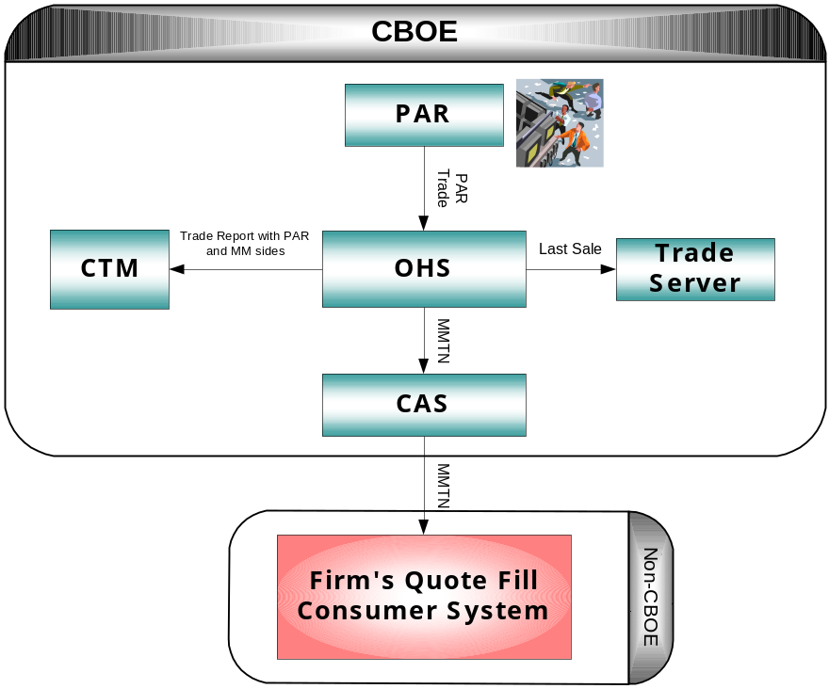

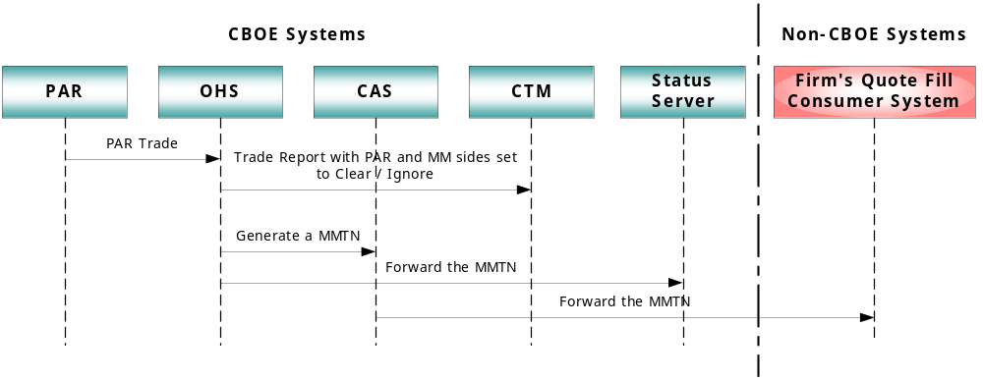

When a MMHH trader trades with PAR then the PAR Broker enters a trade through PAR that goes to OHS. In the PAR Trade, PAR populates the basic accounting info of the MMHH trader from the Market Maker’s profile. Upon receipt of the PAR Trade, OHS does the following:
- sends a MMTN to the related CAS to be forwarded to the firm to notify the MMHH trader that actually traded with PAR
- sends an Internal Ticker Detail to HyTS to generate the Last Sale Report for SELL side
- forwards to CTMr the PAR side and MM side of the PAR Trade

New Parameters

- A new Firm Property of ‘Firm Mapping for Floor Trades’ must be created to associate an acronym to a CMi/FIX Login/UserId thus creating a mapping table
  - The Acronym or UserId must not be allowed to be added if that Acronym or UserId does not exist in the User Profile
  - The unique allowed combinations must be either Class/Acronym/UserId or Post-Station/ Acronym/UserId
  - There must be a provision to create a Acronym/UserId combination for DEFAULT class that will be looked up by the system in case there is no specific class mentioned
- Because of roll-out implications there must be a new Firm Property for enabling / disabling the generation of MMTNs to a firm very similar to the existing Firm Property of ‘Firm Electronic Trade Notification Parameter’
  - A new Firm Property of "Firm Market Maker Trade Notification Parameter" must be created with the fields of ‘Market Maker Acronym’ and ‘MMTN Indicator’ (i.e. TRUE or FALSE)
  - The default value must be set to FALSE for all firms
  - If TRUE then the MMTN is generated and if FALSE then MMTN is not generated
- The existing ‘Firm Electronic Trade Notification Parameter’ and the new ‘Firm Market Maker Trade Notification Parameter’ properties must co-exist. A firm must be allowed to be configured to receive both an ETN and a MMTN at the same time and accordingly the system must generate and deliver the notifications to that specific firm but the clearing of the MMTN/MM side of the trade must be controlled by a different firm property.

- A new Firm Property of ‘Market Maker Trade Report Generation’ must be created which can be set to TRUE or FALSE. Independent of the MMTNs being generated or not this property must behave as follows
  - If TRUE then the MM side of the Trade Report must be set to Clear
  - If FALSE then the MM side of the Trade Report must be set to Ignore
- For PAR side clearing evaluations the system must continue to use the existing Firm Property of ‘Firm Trading Parameter’ with possible values of ‘Clear (C), Defer (D), Ignore (I)’

Market Maker Trade Notification (MMTN) details

- When the PAR trade is received by OHS then OHS must generate a CMi based Quote Fill Message which will be referred to hereafter as a Market Maker Trade Notification (MMTN)
- The MMTN must be structured based on the existing Quote Fill Report. Additionally, there must be some indication in the message that the users will be able to interrogate to determine that the received Fill Report is a MMTN Fill Report like by having QuoteId set to 0 (i.e. zero) and UserAssignedId populated with MMTNId.
- As part of the new interface developed for the MMHH Trade there must be a new method for Controlling subscription of MMTNs based on UserId
(Note: For the list of fields to be populated for a PAR Trade, refer Appendix below)

- On receipt of the PAR Trade, OHS must do the following.
  - Must not validate the Executing Firm
  - Must validate the provided Market Maker acronym details against the user profile in the CBOEdirect system and then the PAR Trade must be handled as follows
    - if the contra information is valid (i.e. at least one Login/UserId exists for the provided MM acronym) then OHS must continue to generate the trade reports and MMTNs as usual
    - if the contra information is invalid (i.e. a Login/UserId does not exist for the provided MM acronym) then OHS must do the following
      - Does not generate a MMTN
      - The MM side of the trade report must be set to Ignore(I)
      - The PAR side of the trade report must be set to ‘Clear (C), Defer (D), or Ignore (I)’ as applicable while still using the invalid contra information
      - Generates a Text Message alert to the Help Desk through SA GUI Message Center indicating that the system has received a PAR Trade with invalid contra information for a specific order
      - Generates an Alert Message to Crowd OMT like an ETN Reject Message indicating that the system has received a PAR Trade with invalid contra information for a specific order
    - If the contra information is valid but if a mapping does not exist in the Firm Property of ‘Firm Mapping for Floor Trades’ to send the MMTN to a specific user then the PAR Trade must be handled similar to the handling done when the contra information is invalid except that the MM side of the trade report must be set to Clear (C) or Ignore(I) as configured in ‘Market Maker Trade Report Generation’ Firm Property

(Note: In the above, Contra information must be validated not only for MM acronym but also by checking to see if the matching acronym found in the user profile also contains the same Firm Number as provided in the contra information. So the Contra information is considered valid only if both the acronym and the Firm Number match.)

- As an MMTN is only a notification of the trade it is not required to be either accepted or rejected by the individual Market Maker and hence there will be no time-out mechanism
- MMTNs must be routed to a configured CMi/FIX Login/UserId applicable for that submitted PAR Trade using the ‘Firm Mapping for Floor Trades’ firm property
- The Status Server must handle the MMTNs similar to the existing handling of a Quote Fill Report like for the purposes of Queuing, and Poss Resend
- MMTNs must be allowed to be generated in all product states
- Last Sale Report must be generated for all PAR Trades
- If the PAR Trade is for a strategy product then a MMTN must be generated for each Market Maker on each leg of the strategy product similar to currently generating an ETN
- In the API the Market Maker must be provided with the ability to DELETE the MM side of a PAR Trade. For a MM trade to be deleted a MM must provide the ProductKey, Acronym, and TradeId at the package level and they all must match.

- There must be a provision to notify Market Makers who actually were not participants in the submitted PAR Trade but a MMTN was created for that trade because of mistaken contra information. The MM must register a special call-back at CAS level with a ClassKey = 0 in order to receive MMTNs for all other classes that the MM is not exclusively registered with.

- When a PAR trade is received by OHS, on the event of OHS noticing that the mapped CMi users are not logged-in during that time, then the PAR Trade must be handled similar to the handling done when the contra information is invalid

- The handling at the package level for bundled messages received from PAR must be the same as handling done for the first part of the bundle for that firm based on the results from its contra information validation. (For example, if a cmi user was logged out during the first part of the bundle but then is logged in for the remainder of the parts, all the parts will be set to Ignore as they will follow the clearing of the first part of the bundle received.)

Trade generated from Market Maker Hand Held(s)

Business Flow and Sequence Diagrams

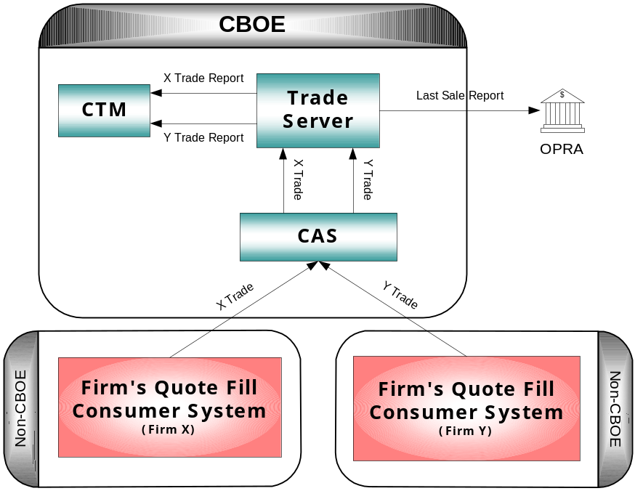

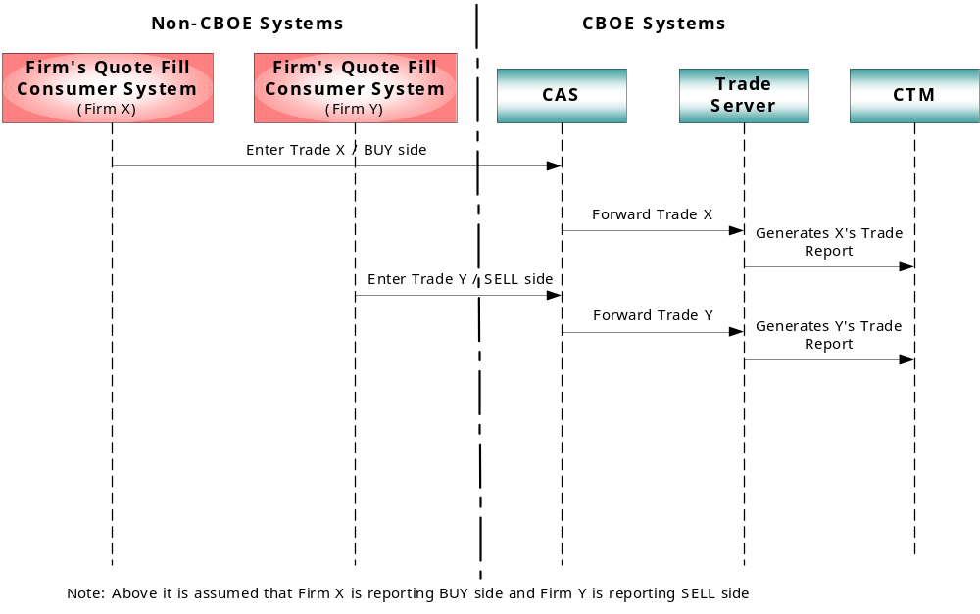

MMHH to MMHH Trade

- When a MM trades with another MM, each MM must input the trade details for his side along with some basic details of the contra party

- On receipt of the MMHH Trade, CBOEdirect must do the following
  - CAS/FE must validate the Product Key
  - HyTS must ignore the values provided by the MM for Executing Firm, Account, and Sub-Account
  - HyTS must not validate any contra details like Contra Firm and Contra Acronym
  - Using the Login/UserId, HyTS must look up the user profile for the acronym applicable for that Login/UserId
    - if the MM provided acronym matches the acronym in the user profile then the system must continue to use the MM provided acronym
    - if the MM provided acronym does not match the acronym in the user profile then the system must do an inverse look up of the Login/UserId in the newly created Acronym-UserId Mapping Table and find the associated acronym for that Login/UserId
      - if the MM provided acronym matches the acronym in the Mapping Table then the system must continue to use the MM provided acronym
      - if the MM provided acronym does not match the acronym in the Mapping Table then the system must generate a Data Validation Exception and reject the MMHH Trade

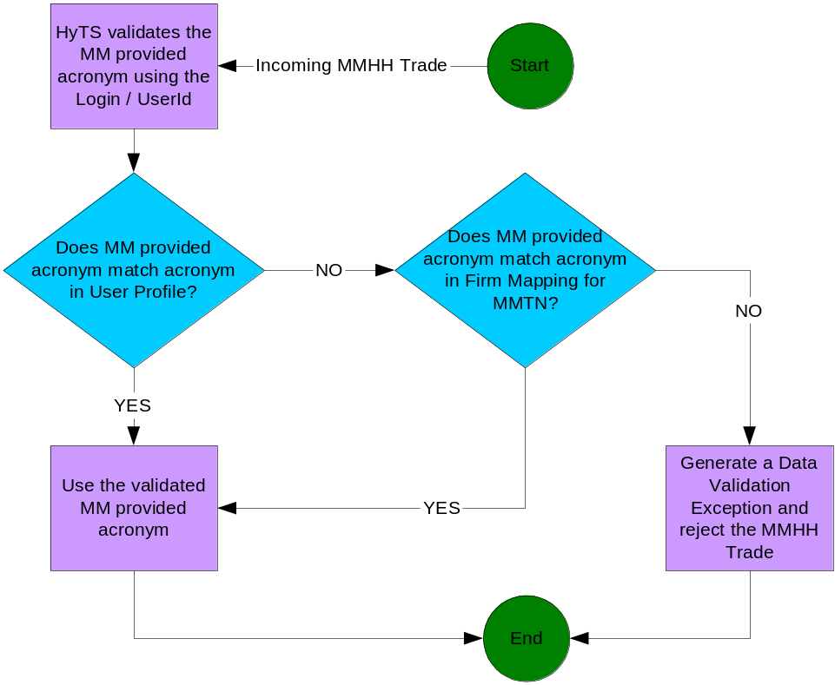

Example:
- Incoming MMHH Trade with Login/UserId “ABC1” and acronym “XYZ”
- HyTS looks up in the User Profile and finds that the associated acronym for Login/UserId “ABC1” is ABC
- As acronyms ABC and XYZ do not match, HyTS looks up in the ‘Firm Mapping for Floor Trades’ Firm Property
    - If it finds that there is a mapping for ABC1 and if it is XYZ then it will use XYZ
    - If it finds that there is a mapping for ABC1 and if it is not XYZ but is DEF then it will reject the MMHH Trade

  - After the acronym has been finalized for the MMHH Trade then using that acronym, HyTS must look up the user profile for the Executing Firm, Account, and Sub-Account applicable for that acronym and thus must use those looked up values for creating the Trade Reports instead of the ones actually provided by the MM even in those cases where the MM has populated any of these optional fields

- The individual MMHH Trade is forwarded to the Trade Server and the TradeId is provided to the MM submitting the trade
- For the reported side, the Trade Server generates a Trade Report, persists it and publishes it to CTMr. Additionally Fill Reports are not generated.
- Last Sale Report must be generated after the SELL side MMHH Trade is processed
- MMHH Trades must be accepted by Trade Server during all product states

- In the API the Market Maker must be provided with the ability to DELETE a MMHH Trade. For a MMHH trade to be deleted a MM must provide the ProductKey, Acronym, and TradeId at the package level and they all must match.

- Currently for MMHH Trades received by CTMr from the MMHH, CTMr sends out Real-Time Communication (RTC) messages to firms through CTMi. But as in the new system the MMHH Trades will be sent to CTMr through the HyTS instead of directly from the MMHH, in order to identify a MMHH Trade from a regular Non-MMHH Trade, a new ‘Trade Type’ of ‘H’ must be added to represent a MMHH to MMHH trade
- In the Trade Reports sent by HyTS to CTMr the following details must be provided
  - Trade Type must be marked as “H” indicating that it is a MMHH Trade
  - Trade Source must be “MARKET_MAKER_MANUAL”
  - Clearing Type must be “CLEAR” for the Executing side and “IGNORE” for the Contra side
  - Billing Type must be “CROSS” on both sides

- Help Desk and Market Replay must be able to filter on MMHH Trades and PAR Trades whose unique trade-types will be “H” and “P” accordingly

MMHH Trade Handling

- A new interface must be developed for the MMHH Trade with new methods for
  - Generating a MMHH Trade
  - Deleting a MMHH Trade based on TradeId
- The system must validate that only Market Makers (i.e. Market_Maker (M) and DPM_Role (D)) are able to submit a MMHH Trade
- The Contra party must be allowed to be of other roles than Market Maker. The contra information must not be validated for existence check.
- The following are the fields to be populated for input of a MMHH Trade

Input Field Name | Mandatory or Optional Input | Valid Format Check | Valid Range Check | Existence Check
Trading Session Name | Mandatory |  |  | √
Product Key | Mandatory |  |  | √
Quantity | Mandatory | N/A | √
Price | Mandatory | N/A | √
Side | Mandatory |  |  | √
Executing Broker Acronym | Mandatory | √ |  | √
Contra Broker | Mandatory | √
Contra Firm | Mandatory | √
Position Effect | Optional |  |  | √
Account | Optional
Subaccount | Optional
CMTA (Exchange + Firm) | Optional |  | √ (Firm) | √ (Exchange)
Executing Firm | Optional
Optional Data | Optional

N/A – Not Applicable
√ - Validated
Blank cell means that it is not validated for that specific check

(Refer Appendix 3.1 and below for the Hard and Soft Edit Error details generated currently by CTMr)

Appendix

Hard Edit Errors generated currently by CTMr

System Error Code | Error Type / Message | Error Cause | Action To Be Taken
"HARD" edit error #1 | Trade Date Invalid | 1) Format "YYYYMMDD" incorrect.  2) Trade date not equal to TMS Trade Date. | Re-send transaction after trade date has been corrected.
"HARD" edit error #2 | Executing Firm Invalid | 1) Firm number not numeric.  2) Firm number not found on valid firm database. | Re-send transaction after executing firm is corrected.
"HARD" edit error #3 | Executing Acronym Invalid | 1) Executing acronym not found on valid broker database. | Contact Help Desk immediately. Re-send transaction after executing broker has been corrected.
"HARD" edit error #4 | Class Symbol Invalid | 1) Class symbol not found on TMS class database table. | Re-send transaction after class symbol has been corrected.
"HARD" edit error #5 | Duplicate Add Transaction | 1) Transaction was submitted with a transaction sequence number identical to a previous transaction. | Re-send transaction after changing the transaction sequence number.
"HARD" edit error #6 | Trade Record Not Found (Change and Delete Transactions Only) | 1) Transaction number was not on the TMS Master Trade Database.  2) Trade record on the TMS Master Trade Database was deleted by the clearing firm. | 1) Re-send transaction after transaction sequence number has been corrected.  2) Re-send change transaction as an add transaction.
"HARD" edit error #7 | Transaction Code Invalid | 1) Transaction code was not an "A" (add), "C" (change) or "D" (delete). | Re-send transaction after transaction code has been corrected.

Soft Edit Errors generated currently by CTMr

System Error Code | Error Type / Message | Error Cause | Action To Be Taken
"SOFT" edit error #1 | Contra Firm Invalid | 1) Firm number not numeric.  2) Firm number not found on valid firm database. | Correct contra firm
" SOFT " edit error #2 | Contra Broker Invalid | 1) Broker acronym not found on valid broker database. | Correct contra broker
" SOFT " edit error #3 | Market-maker Account Invalid | 1) Market-maker broker not found on valid broker database. This field was referred to earlier as joint_acct_code. It is also called "Q" account or ACA, Alternate Clearing Account. | Correct market-maker broker
" SOFT " edit error #4 | Buy / Sell Code Invalid | 1) Buy / sell code was not a "B" or "S". | Correct buy / sell code
" SOFT " edit error #5 | Contract Quantity Invalid | 1) Contract quantity was not a numeric value. | Correct contract quantity
" SOFT " edit error #6 | Series Invalid | 1) Series not found on valid series database. | Correct series
" SOFT " edit error #7 | Premium Price Invalid | 1) Premium integer was not a numeric value.  2) Premium fraction was not expressed in 16ths. | Correct premium price

Fields for PAR Trade

The following are fields to be populated for a PAR Trade
- orderId
- productKey
- sessionName
- executionPrice
- tradeDateTime
- tradeBookPrice
- tradeBookSize
- tradedQuantity
- contraBrokers
- marketDataWhenReceived
- marketDataWhenSelected
- marketDataWhenTraded
- highLowNbboBidAskPrice
- highLowCboeBidAskPrice
- highLowNbboBidAskExchange
- nbboBidExchanges
- nbboAskExchanges
- nbboTime
- cboeTime
- awayExchange
- fadeExchange
- lastSaleIndicator
- linkageFillIndicator
- mmqAccount
- marketabilityIndicator
- legRatios
- legTradedQuantities
- legExecutionPrices
- theoryExecutionPrice
- cboeQuoteInfo
- tradeBookInfo
- tradeBookInfoWhenReceived
- tradeBookInfoWhenSelected
- tradeBookInfoWhenTraded
- tradeBookInfoHighLow
- parBroker
- workStationId
- totalBundleCount
- bundleSequenceNumber
- currentBundleNumber
- totalBundleTradedQuantity
- meetLocation
- meetFirm

Open Issues/Questions

Topic Related To | Issue Description
MMTN generated from OHS | (1) For generating a MMTN, would we need to create a separate Quote Object/Id internally in the Trade Service or can we do without that?
MMHH to MMHH Trade | (1) For processing a MMHH Trade, would we need to create a pseudo Quote or Order just to compensate the fact that there are no actual Quote or Order Objects that exist which are trading here and also as it is just a notification from the Handheld with only limited details?

Abbreviations and Acronyms

Item | Description
CTM | CBOE Trade Match system
ETN | Electronic Trade Notification
MDR/MTL | Market Data Retrieval / Matched Trade Listing
MMHH or MMT | Market Maker Hand Held or Market Maker Terminal system
MMTN | Market Maker Trade Notification
NCC | Non-CBOE Computer
OHS | Order Handling Service in CBOEdirect
PDS | Post Data Server
RTC | Real-Time Communication
TAT | Trade Acknowledgement Ticket
TPF | Transaction Processing Facility

